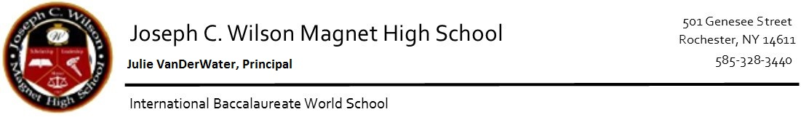
Frequently Asked Questions

Bus Pass process
Students receive the initial bus pass/ID upon entry to school year. They are allotted one replacement per year. After the replacement is lost, Parent or student has to purchase one at RCSD transportation department. The address is 835 Hudson Ave, Building 1 Rochester, NY 14621. These bus passes are equivalent to money for transportation. If they do not have a bus pass, they are responsible to pay to get on the bus. Replacement passes are $3.00 and are to be paid at the RCSD transportation office.

Lunch
This is a closed campus. Students are not able to leave and return during school time. Students are not able to use food services to bring food to the school as well. If you wish to bring lunch for your child, Please bring it during their assigned lunchtime. Staff are unable to interrupt learning sessions for meals brought to the school.

Updating Student’s Information
Only guardians are able to change any information for a student. Address changes requires a bill/lease/home agreement in order for it to be changed. It takes 3 working days to change in the system. In order to take an RTS assigned route, student must live 1.6 miles or farther.

Pick up/Drop off/Early dismissal
Only those listed on the school system are able to pick up a student. If a guardian would like to add/change the list, please call 328-3440 ext. 1000 to do so. Students registered in school are unable to authorize dismissals or absences, regardless of age. If students are being approved for early dismissal, transportation has to be set up by the parent/student. Main office staff cannot give bus passes.

Excused absences
Religious holidays, illness or medical appointments with notes from doctor, are the only approved excused absences.
Emergency School Closings
In event of poor weather or any other emergency, local radio and television stations will broadcast information about closings, delayed starts and other emergencies. Parents are encouraged to arrange for the supervision of their children before any emergencies arise.

Work permits
Students younger than 18 must have a work permit to get a job. The school nurse will provide you with the information you need to obtain a work permit.

